NAME: JENOVIC MUKASA
Student number: st10474303 WEBDEV PART 2
SHAM SCHAWARMA & GRILL WEBSITE PROJECT PROPOSAL

Table of content
1 ORGANISATION OVERVIEW PG 2
2 WEBSITE GOALS AND OBJECTIVES PG 3
3 CURRENT WEBSITE ANALYSIS PG 5
4 PROPOSED WEBSITE FEATURES AND FUNCTIONALITY PG 6
5 DESIGN AND USER EXPERIENCE PG 7
6 USER EXPERIENCE CONSIDERRATIONS PG 10
7 TECHNICAL REQIREMENTS PG 11
8 TIMELINE AND MILESTONES PG 13
9 BUDGET ESTIMATION PG 13
REFERENCES PG 15

1 ORGANISATION OVERVIEW

Organization: Sham Schawarma and grill
Industry: Hospitality
Location: 295 Florida road, Florida Fields, Windermere, Berea, Durban, 4001
Website status: New development required
Website published on: https://github.com/JeNo99/ST10474303--PART-2

BRIEF HISTORY
Sham Shawarma and Grill was founded to introduce authentic Middle Eastern cuisine to the local community. Drawing inspiration from Jordanian and Palestinian traditions, the restaurant has become well-known for its freshly made shawarmas, grilled dishes, and inviting atmosphere. Over time, it has gained a loyal following due to its commitment to quality, affordability, and strictly halaal offerings.
The Middle Eastern restaurant Sham Schawarma & Grill is situated on Florida Road in Durban. Authentic shawarma, grilled meats, falafel, kebabs, hummus, and other typical Middle Eastern meals are the restaurant's specialties. Freshly cooked meals and a family-friendly dining experience have made it famous for introducing Middle Eastern delicacies to Durban.
The historical region of Bilad al-Sham (Greater Syria), which comprises present-day Syria, Lebanon, Jordan, and Palestine, is referred to as "Sham." The restaurant is inspired by the region's rich culinary traditions, especially the well-known shawarma, which has its roots in Ottoman-era techniques for roasting meat on a vertical spit.
Sham Schawarma & Grill, which serves both dine-in and takeout customers in Durban, is now well-known in the area for its authentic Middle Eastern food, which includes beef and chicken shawarma wraps, mixed grill platters, falafel meals, and fresh juices.
MISSION STATEMENT
“The mission of Sham Schawarma and Grill is to serve fresh, flavorful, and authentic meals made with quality ingredients and traditional recipes. The restaurant is committed to maintaining excellent food standards, delivering fast and friendly service, and ensuring that every customer leaves satisfied.”
VISION STATEMENT
“The vision of Sham Schawarma and Grill is to become a trusted and well-recognized destination for authentic Middle Eastern cuisine. The restaurant strives to create memorable dining experiences where customers can enjoy high-quality food, friendly services, and a welcoming atmosphere inspired by Middle Eastern hospitality.”

TARGET AUDIENCE
Sham Schawarma & Grill's target market consists of:
1. Students and young adults seeking quick, tasty, and reasonably priced meals.
2. Professionals in the workforce who desire easy lunch and dinner options.
3. Families looking for a range of food options and a relaxed dining experience.
4. Middle Eastern foodies who enjoy grilled foods, falafel, kebabs, and authentic shawarma.
5. Visitors and tourists discovering Durban's culinary scene, particularly in the Florida Road area.
6. Clients who are concerned about halal food, since Middle Eastern eateries frequently accommodate halal dietary requirements.

2 WEBSITE GOALS AND OBJECTIVES

WEBSITE GOAL
The primary aim of the Sham Shawarma and Grill website is to build a strong digital presence that markets the business, draws in new customers, and enhances the overall customer experience. It is designed to provide easy access to information while boosting brand visibility and increasing sales.
WEBSITE OBJECTIVES
- To display accurate and updated details about the menu, pricing, location, and trading hours
- To showcase the restaurant’s strictly halaal meals and distinctive Middle Eastern dishes
- To offer convenient features such as online ordering and communication options
- To attract potential customers through visually appealing and engaging content
- To encourage customer retention by promoting specials, deals, and updates
- To improve the brand’s image and maintain competitiveness in the online market

KEY PERFORMANCE INDICATORS (KPIs) TO MEASURE SUCCESS
KPI | What It Measures |  | Targert
Website Traffic | Number of visitors to the website. |  | Increase visitors by 20% within 6 months.
Online Orders | Number of orders placed through the website. |  | Achieve at least 100 online orders per month.
Conversion Rate | Percentage of visitors who place an order or make an enquiry. |  | Reach a conversion rate of 5% or higher.
Bounce Rate | Percentage of visitors who leave after viewing only one page. |  | Keep below 40%.
Average Session Duration | How long visitors spend on the website. |  | More than 2 minutes per visit.
Mobile User Satisfaction | Performance and usability on mobile devices. |  | Maintain a mobile-friendly score above 90%.
Menu Page Views |  | Number of times the menu page is viewed. |  | Increase menu views by 30% within 3 months.
Customer Enquiries |  | Number of contact forms or enquiries received. |  | Generate at least 20 enquiries per month.
Customer Reviews and Ratings |  | Feedback received through the website or linked platforms. |  | Maintain an average rating of 4.5/5 or higher.
Page Load Speed |  | Time taken for website pages to load. |  | Load pages within 3 seconds.

3 CURRENT WEBSITE ANALYSIS

REASON FOR CHOOSING TO CREATE A WEBSITE FOR SHAM SHAWARMA AND GRILL
The decision to develop a website for Sham Shawarma and Grill is based on the growing importance of having an online presence in today’s digital world. The company does not have a website currently and creating this website will give get them more attention that will attract people. This website will allow the business to promote its menu, highlight its strictly halaal offerings, and attract a wider audience beyond walk-in customers. It also makes it easier for customers to access important information such as location, operating hours, and contact details at any time.
Additionally, the website will improve customer convenience by enabling features such as online ordering, menu browsing, and updates on promotions or specials. This would increase customer satisfaction and encourage repeat business. Having this professional website also enhances the restaurant’s credibility and competitiveness within the food industry, especially as many customers rely on online platforms when choosing where to eat.
Furthermore, the website can serve as a marketing tool by showcasing images of food, sharing customer reviews, and integrating with social media platforms. This helps to strengthen brand awareness and build stronger relationships with customers.
ADVANTAGES OF THE NEW SHAM SCHAWARMA & GRILL WEBSITE
1. Provides Crucial Information: The website contains crucial information including the restaurant’s location, menu, and contact data.
2. Simple Navigation: Users have little trouble navigating between pages like Home, Menu, and Contact.
3. Visual Appeal: Using pictures of food draws consumers and highlights the restaurant’s offerings.
4. Brand Promotion: The website uses its logo, colors, and content to highlight the restaurant’s identity.
5. Accessible 24/7: Without having to physically visit the restaurant, customers can access information about it at any time.
6. Mobile Accessibility: Customers can easily visit the website from computers, tablets, and smartphones.
7. Cost-effective Marketing Tool: The restaurant can reach a larger audience by using the website as an online marketing platform.
8. Menu Availability: This enhances convenience by allowing customers to peruse menu items before to visiting or placing an order.

4 PROPOSED WEBSITE FEATURES AND FUNCTIONALITY

CORE PAGES
1. Home
2. About us
3. Contact us
4. Menu
5. Reservation

KEY FUNCTIONALITY
- Digital Menu – Customers can browse the restaurant's food and drink options online, making it easier to decide what to order.
- Online Ordering System – The website allows customers to place orders electronically, providing a fast and convenient ordering process.
- Communication Details – Essential contact information, including phone numbers, email addresses, and social media accounts, is available for customer enquiries.
- Location Information – Customers can access the restaurant's address and directions, helping them find the establishment with ease.
- Responsive Design – The website adapts to different screen sizes and devices, ensuring a smooth browsing experience on mobile phones, tablets, and computers.
- Photo Gallery – Images of menu items and the restaurant environment help attract customers and provide a visual representation of the brand.
- User-Friendly Navigation – Clearly organized menus and links allow visitors to move between different sections of the website efficiently.
- Online Enquiry Feature – Customers can submit questions, comments, or requests through an online form, improving communication with the business.
- Social Media Connections – The website links to social media platforms, enabling customers to stay informed about updates, promotions, and new offerings.
- Special Offers and Promotions – Promotional content can be displayed on the website to inform customers about discounts and featured meals, helping to increase sales.

5 DESIGN AND USER EXPERIENCE

DESIGN AESTHETIC AND BRANDING
The orange and black color scheme of the Sham Schawarma & Grill website creates a unique and captivating online presence. The black components add to a polished and contemporary appearance, while the warm orange hues help evoke a feeling of vitality and appetite appeal. The website successfully conveys the restaurant's identity and ideals through appealing culinary photos, an adaptable style, and consistent branding elements. The user experience is improved and brand recognition is increased when colors, images, and messaging are consistent.
TYPOGRAPHY
Element | Type | Example from Website | Purpose
Main Website Title | Large Bold Sans-Serif | "SHAM SHAWARMA AND GRILL" | Establishes brand identity and attracts attention.
Page Headings | Large Bold Sans-Serif | "Welcome to Sham Shawarma & Grill", "About Us", "Get In Touch" | Highlights key sections and improves readability.
Navigation Menu | Medium Bold Sans-Serif | Home, About, Contact, Menu, Reservation | Allows users to navigate the website easily.
Subheading/Tagline | Regular Sans-Serif | "Authentic Middle Eastern Cuisine" | Provides supporting information about the brand.
Body Text | Regular Sans-Serif | About Us description and contact information | Communicates detailed information clearly.
Form Labels | Medium Bold Sans-Serif | "Full Name", "Email Address" | Guides users when completing forms.
Footer Text | Small Sans-Serif | Operating Hours | Displays supplementary information without dominating the page.

LAYOUT AND DESIGN APPROACH
Layout and Design Approach of the Sham Schawarma & Grill Website
- The website uses a straightforward and easy-to-use design, allowing visitors to find information quickly.
- A uniform header section appears on each page, displaying the logo, restaurant name, slogan, and navigation links.
- The content is arranged in a simple vertical layout, which helps users focus on the information being presented.
- Information is divided into well-defined sections with prominent headings, making the content easier to read and understand.
- The orange and black colour palette is consistently applied across the website, reinforcing the restaurant's brand image.
- A clearly structured navigation bar enables users to move easily between different pages of the website.
- Different font sizes are used to create a clear visual structure, helping users identify key information at a glance.
- Adequate spacing between sections contributes to a neat and organised appearance.
- The website is designed to be responsive, ensuring it functions effectively on computers, tablets, and smartphones.
- The overall design prioritises ease of use and accessibility, enhancing the visitor's browsing experience.
- Strong colour contrast between text and backgrounds improves readability and visual appeal.
- Consistent use of design elements, typography, and colours gives the website a modern and professional look.

6 USER EXPERIENCE CONSIDERATIONS

- The website provides simple and intuitive navigation, allowing users to move between pages without confusion.
- The orange and black colour scheme creates strong contrast, making text and important information easy to read.
- Large headings and clear typography improve readability and content accessibility.
- The layout is clean and uncluttered, helping users focus on the most important information.
- Important sections such as the Home, About, Menu, Contact, and Reservation pages are easily accessible through the navigation menu.
- The dedicated Reservation page allows customers to conveniently book a table online, improving customer service and enhancing the overall user experience.
- The website maintains consistent branding and design elements across all pages, creating a familiar and professional experience for users.
- Content is organised into logical sections, making information easy to locate and understand.
- The responsive design ensures that the website can be viewed effectively on mobile phones, tablets, and desktop computers.
- High-quality visuals and branding elements help create a more engaging browsing experience.
- The website's simple design reduces the learning curve for first-time visitors and improves usability.
- Contact information is clearly displayed, enabling users to communicate with the restaurant easily.
- Quick access to essential information and reservation facilities improves customer convenience and satisfaction.
LOW-FIDELITY WIREFRAMES – KEY SCREENS
Screen/Page | Main Elements Included
Home Page | Logo, restaurant name, navigation menu, welcome message, video, footer
About Page | Logo, navigation menu, About Us heading, restaurant history, mission and vision statement, footer
Menu Page | Logo, navigation menu, menu categories (Shawarma, Grills, Deserts, Drinks), food items, footer
Reservation Page |  | Logo, navigation menu, reservation form (Name, Email, Date, Time, Number of Guests), Book Table button, footer
Contact Page |  | Logo, navigation menu, contact form, address, phone number, email address, map, footer
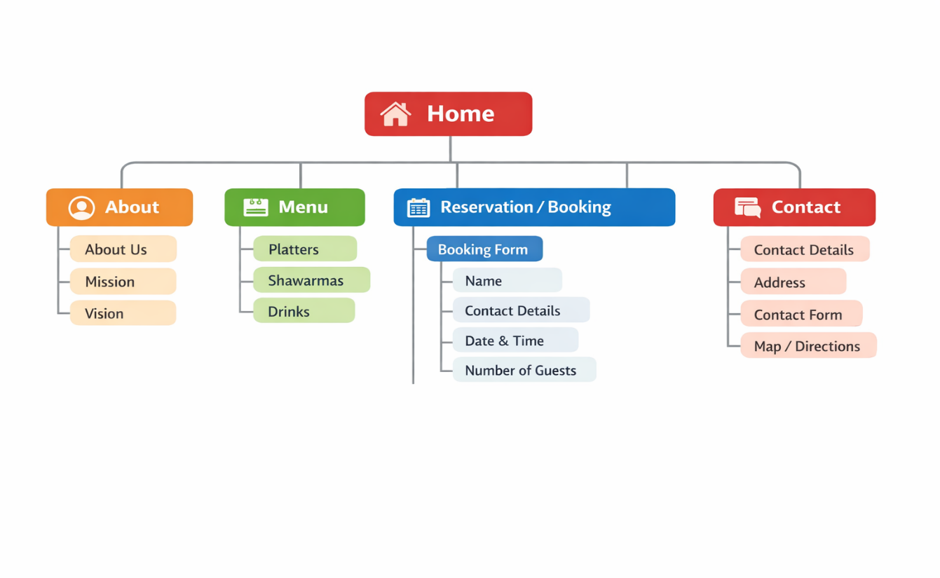

7 TECHNICAL REQUIREMENTS

Requirement Category | Technical Requirement
Hardware | Computer or laptop for website development and maintenance.
Internet Connection | Stable internet connection for website hosting, updates, and user access.
Web Hosting | Reliable web hosting service to store website files and ensure availability.
Domain Name |  | A registered domain name (e.g., shamshawarma.co.za).
Frontend Technologies |  | HTML5, CSS3, and JavaScript for creating the website interface and functionality.
Backend Technologies |  | PHP, Node.js, or similar technology for handling forms and reservations.
Database |  | MySQL or similar database system to store reservation and contact form data.
Responsive Design |  | Website must be compatible with desktops, tablets, and smartphones.
Web Browser Compatibility |  | Support for Google Chrome, Mozilla Firefox, Microsoft Edge, and Safari.
Security |  | SSL certificate (HTTPS) to secure user data and website communications.
Navigation System |  | Functional navigation menu linking Home, About, Menu, Reservation, and Contact pages.
Reservation System |  | Online booking form with validation for customer reservations.
Contact Form |  | Functional contact form allowing customers to send enquiries.
Performance |  | Website pages should load within 3 seconds for optimal user experience.
Maintenance |  | Regular updates, backups, and security monitoring.

8 TIMELINE AND MILESTONES

Week | Phase | Main Activities
1 | Planning & Research | Define goals, research competitors, identify target audience and features
2-3 | Content Development | Gather content, write text, plan pages and navigation
4-5 | Design Phase | Create wireframes, choose colours and fonts, design key pages
6-9 | Website Development | Build website, add content and images, make it mobile-friendly
10 | Testing & Improvements | Test links and forms, fix errors, improve speed and usability
11 | Finalisation & Submission | Make final changes, check requirements, prepare presentation/documentation

9 BUDGET ESTIMATION

BUDGET DEVELOPMENT FOR SHAM SHAWARMA AND GRILL WEBSITE
Developing a website for Sham Shawarma and Grill requires a planned budget to cover the costs of design, development, and ongoing maintenance. The following is an estimated cost breakdown:
Item | Estimated Cost (ZAR) | Description
Domain Registration | R150 – R300/year | Securing a unique website name (e.g., .co.za domain)
Web Hosting | R1,000 – R2,000/year | Service required to host the website online
Website Design | R2,000 – R5,000 | Creating the layout, visual appearance, and user interface
Website Development | R3,000 – R8,000 | Building and coding the website, including its features
Content Creation | R500 – R1,500 | Preparing written content, images, and menu details
Maintenance and Updates | R1,000/year | Ongoing support, updates, and minor improvements
Total Estimated Cost
Initial Cost: Approximately R6,650 – R16,800
Annual Cost (after launch): Approximately R2,000 – R3,300
The proposed budget is suitable for the development of a small restaurant website and provides sufficient resources to create a professional, functional, and user-friendly online platform. However, the final cost may differ depending on factors such as the website's design complexity, the range of features implemented, and whether the project is completed in-house or by a professional web developer.

REFERENCES
Chaffey, D. and Ellis-Chadwick, F., 2019. Digital Marketing: Strategy, Implementation and Practice. 7th ed. Harlow: Pearson Education.
Krug, S., 2014. Don't Make Me Think, Revisited: A Common Sense Approach to Web Usability. 3rd ed. Berkeley: New Riders.
Laudon, K.C. and Laudon, J.P., 2022. Management Information Systems: Managing the Digital Firm. 17th ed. Harlow: Pearson.
Chaffey, D. and Ellis-Chadwick, F., 2019. Digital Marketing: Strategy, Implementation and Practice. 7th ed. Harlow: Pearson Education.
Chaffey, D. and Ellis-Chadwick, F., 2019. Digital Marketing: Strategy, Implementation and Practice. 7th ed. Harlow: Pearson Education.

